Derrick McFall

Graphic User Interface

12-Nov-17

Chapter 21 #1-3

1. Number 1 was just opening the file.
2. 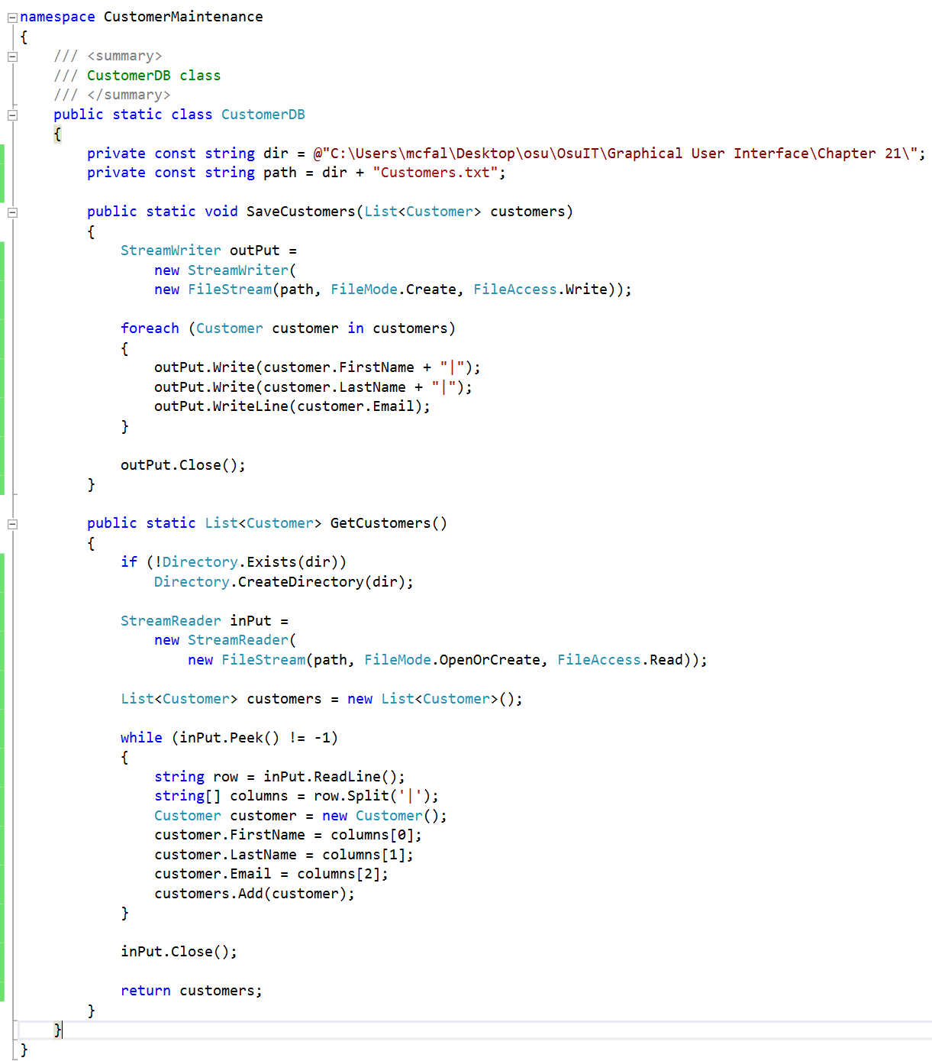  
   Code added : This part tricked me and it took a while to find it. I had to add CustomerDB.SaveCustomers(customers);  
   to the frmCustomers.cs file because it wasn’t saving the data to the file. I needed to use the save customers method. Other code I added as follows :   
    private const string dir = @"C:\Users\mcfal\Desktop\osu\OsuIT\Graphical User Interface\Chapter 21\";

private const string path = dir + "Customers.txt";

public static void SaveCustomers(List<Customer> customers)

{

StreamWriter outPut =

new StreamWriter(

new FileStream(path, FileMode.Create, FileAccess.Write));

foreach (Customer customer in customers)

{

outPut.Write(customer.FirstName + "|");

outPut.Write(customer.LastName + "|");

outPut.WriteLine(customer.Email);

}

outPut.Close();

}

public static List<Customer> GetCustomers()

{

if (!Directory.Exists(dir))

Directory.CreateDirectory(dir);

StreamReader inPut =

new StreamReader(

new FileStream(path, FileMode.OpenOrCreate, FileAccess.Read));

List<Customer> customers = new List<Customer>();

while (inPut.Peek() != -1)

{

string row = inPut.ReadLine();

string[] columns = row.Split('|');

Customer customer = new Customer();

customer.FirstName = columns[0];

customer.LastName = columns[1];

customer.Email = columns[2];

customers.Add(customer);

}

inPut.Close();

return customers;

}

1. 